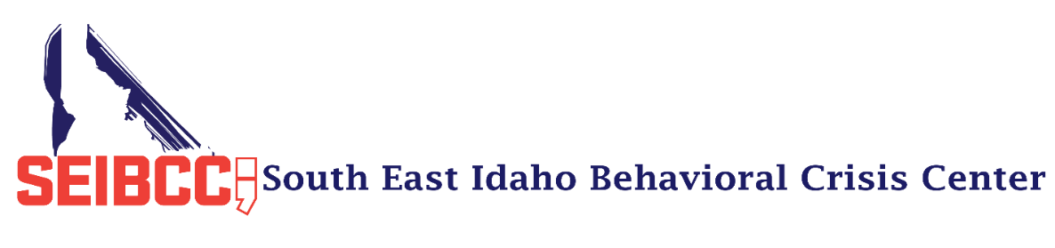

Thank you for your interest in donating to the crisis center. We function on a limited budget; therefore, any type of donation helps the crisis center in one way or another.
There are many ways to donate to the center. Some will make a monetary donation and designate the donation to a specific cause, such as transportation or clothing, and others will donate without a designation. Both types help out tremendously.
The crisis center has a Venmo account. You can find it at SEIBCC_Donations. Please enter your business/group name in the description box so we can keep track of donations.
Other ways to donate are through in-kind donations. Below is a list of items the center uses regularly. Some items are designated as “new” for hygiene purposes.

Paper products
- Paper plates, Plastic Utensils, Napkins, Paper Coffee Cups, Coffee Filters
Snack Food/Drinks
- Ground Coffee, Powdered Juice Mix or Gatorade, Granola Bars, Apple Sauce, Fruit Cups, Instant Oatmeal
Clothing (Must be new)
- Plain T-Shirts, Sweatpants (no strings), Socks, Underwear, Bath Towels
Office Supplies
- Printer Paper, File Folders, Adhesive file folder labels, White Board Markers, Masking Tape
Cleaning Supplies
- Lysol Wipes, Lysol Spray, Disposable Gloves, Laundry Detergent (High Energy Efficient)
Bedding (Must be new)
- Twin Size Fitted and Flat Sheets, Pillowcases, Pillows

Thanks for your interest in the crisis center. Your donation will reach many who are in desperate neeed of help.

Myrna Daniels, B.A.
Executive Director
208-909-5177
mdaniels@bestllc.net

